**Game Snapshots**

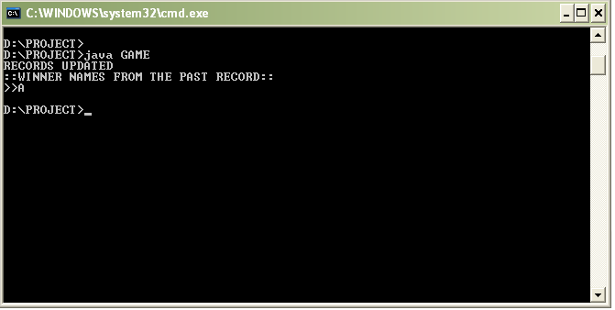  
  
 COMPILATION & WINNER DATA RECORDS  
  
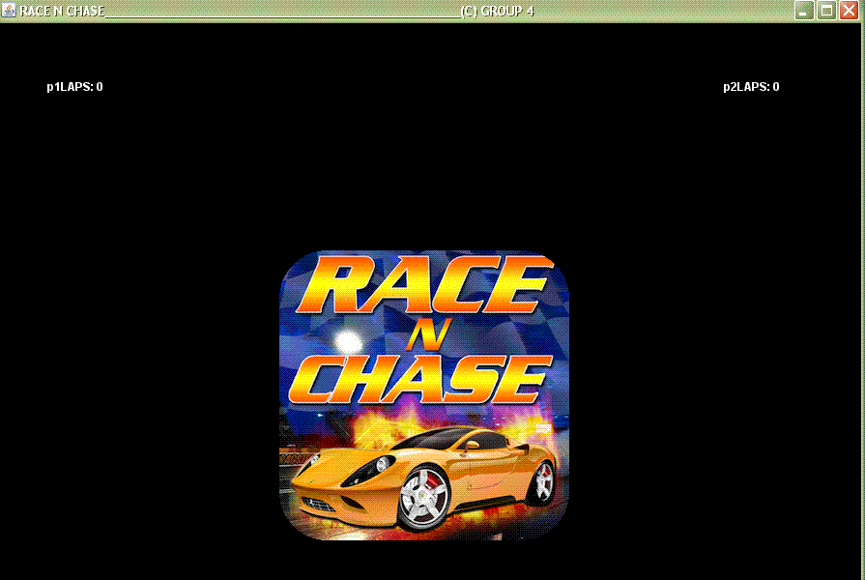  
  
 TITLE SCROLLING DOWN  
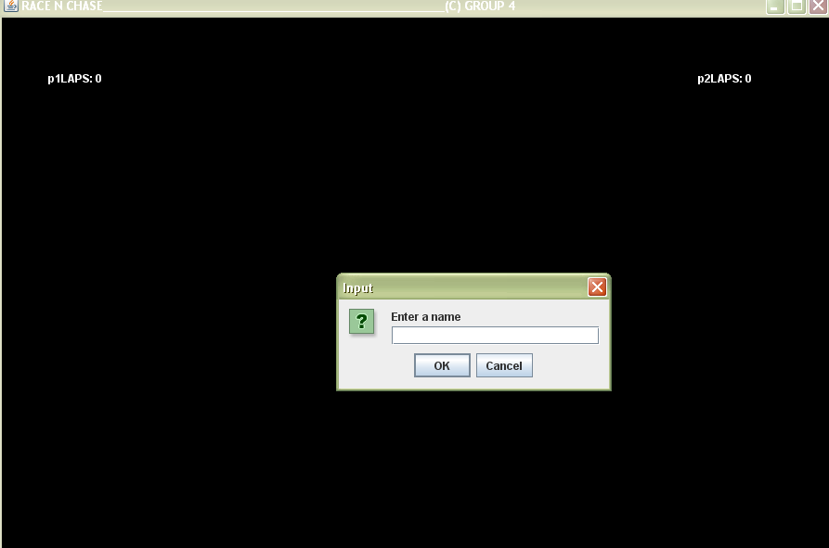

ENTER PLAYER NAME  
  
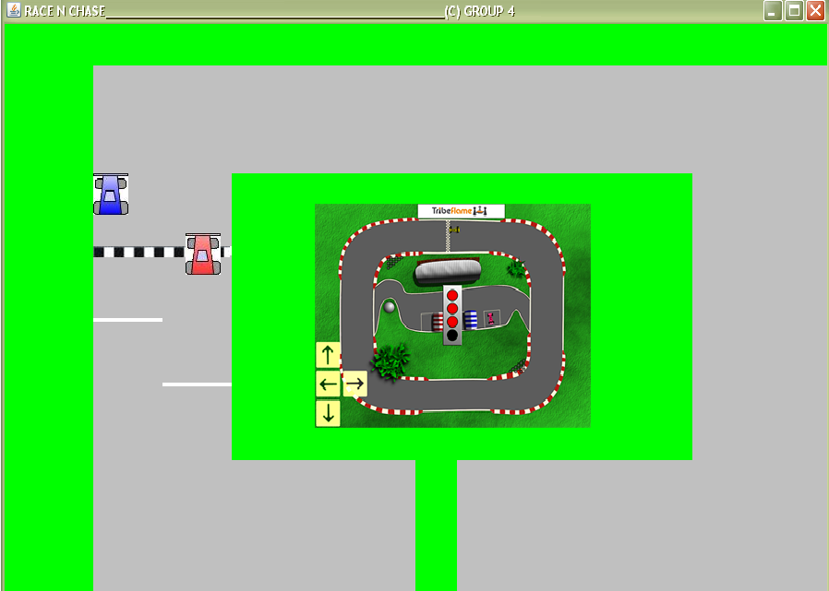  
  
RACE BEGINS  
  
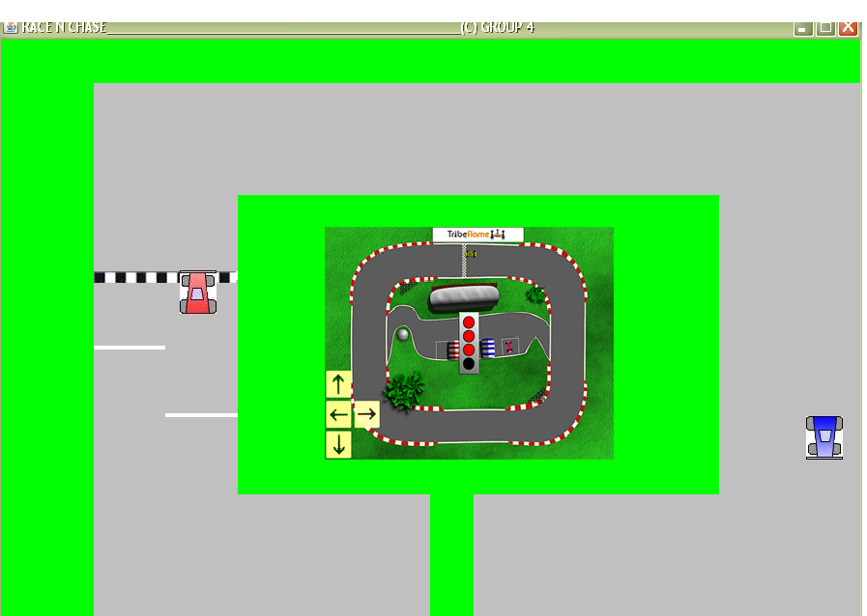   
  
RACE IN PURSUIT  
  
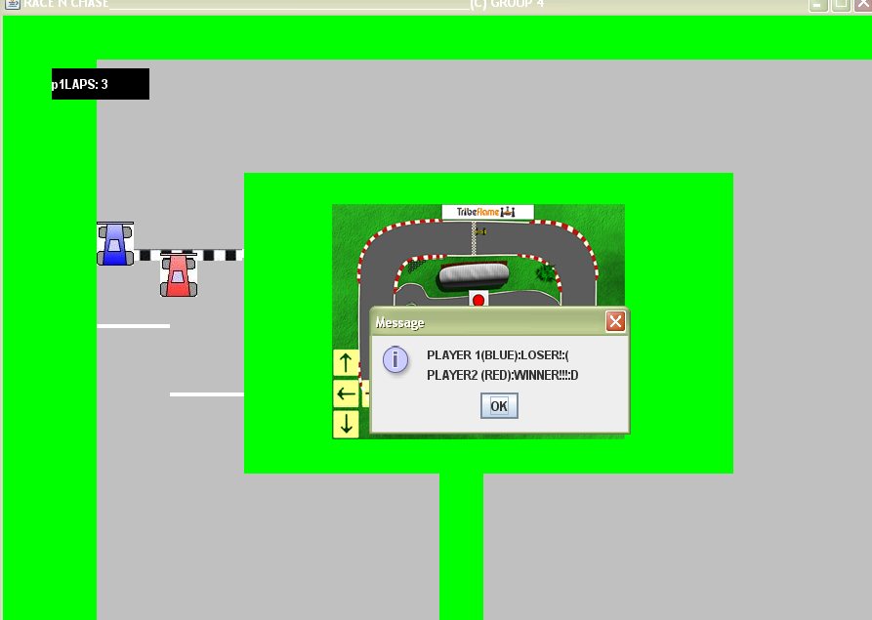  
  
END OF RACE